**WEEK: 9**

**Maps, plots and Amazon’s choice for next office building.**

Prerequisite:

**library**(sf)

**library**(raster)

**library**(dplyr)

**library**(spData)

**library**(spDataLarge)

visualization packages:

**library**(tmap) *# for static and interactive maps*

**library**(leaflet) *# for interactive maps*

**library**(ggplot2) *# tidyverse data visualization package*

## Static maps: Static maps are the most common type of visual output from geocomputation. Standard formats include .png and .pdf for raster and vector outputs respectively. The generic plot() function is often the fastest way to create static maps from vector and raster spatial objects

## **tmap** is a powerful and flexible map-making package with sensible defaults. It has a concise syntax that allows for the creation of attractive maps with minimal code which will be familiar to **ggplot2** users.

### **Map objects:** A useful feature of **tmap** is its ability to store objects representing maps.

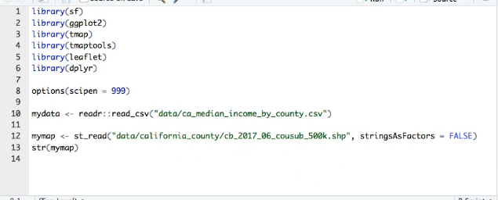

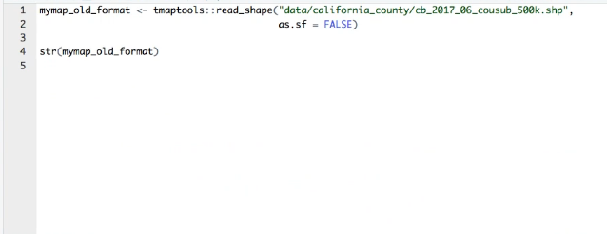

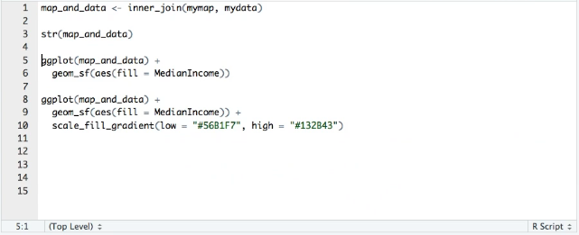

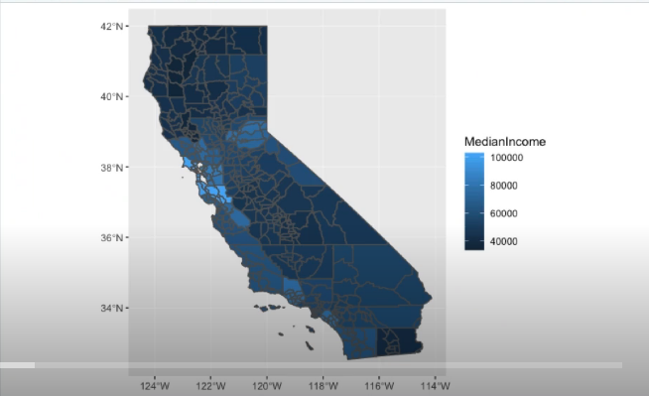

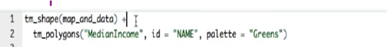

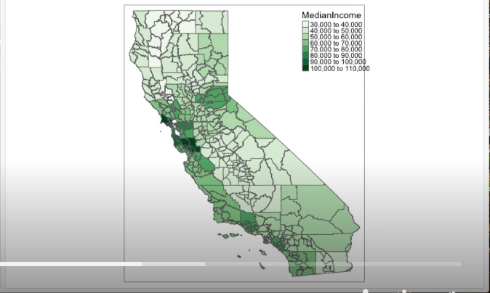

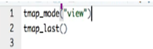

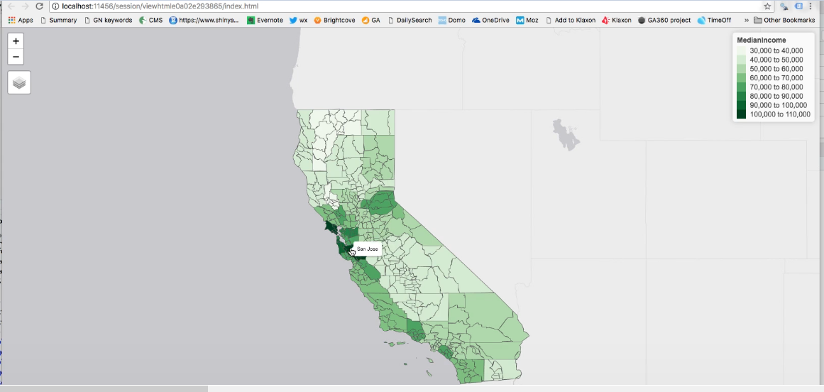

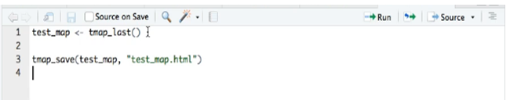

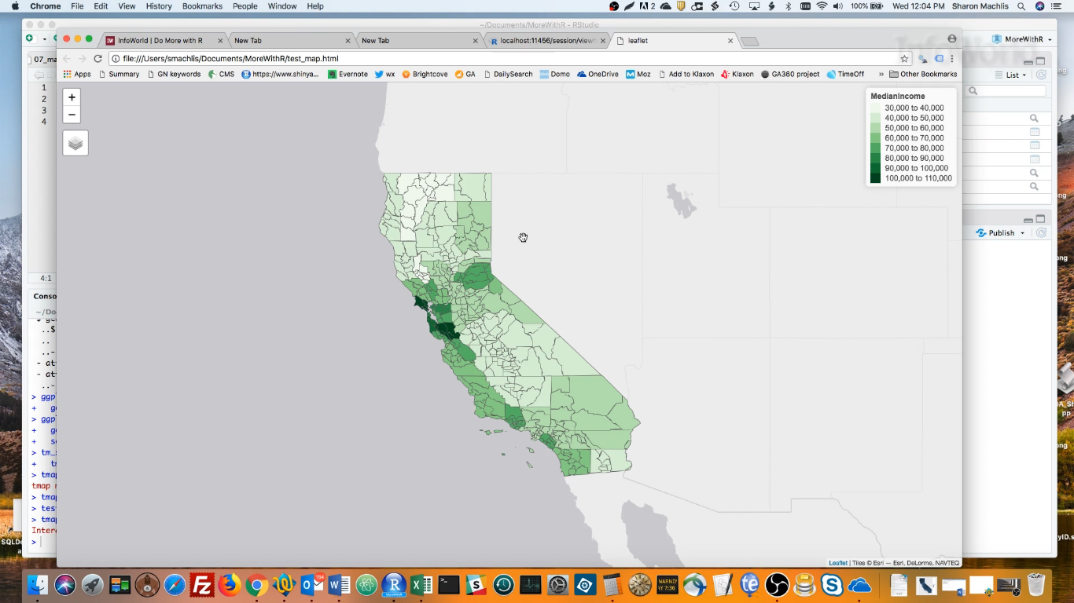

Location Service in Action

